Water Quality Diagnosis Using Classification

Data 1030 Final Report

Jin Hyeok Noh

Brown University

jin_hyeok_noh@brown.edu

GitHub link: https://github.com/jinnoh47/data1030-project/tree/main

1. **Introduction**

**Getting access to safe drinking water is vital to humans’ health, a fundamental human proper and a factor of adequate coverage for health protection. That is critical as a health and improvement trouble at a countrywide, local and nearby stage. In some areas, it has been shown that investments in water supply and sanitation can yield a net economic advantage since the reductions in adverse fitness effects and health care fees outweigh the charges of assigning the interventions.**

**The dataset was provided in Data Portal by the Republic of South Korea. There are 2036 data points and 43 features in this data set. The target variable is potability data indicates that zero is potable and one means not potable. The goal is to examine the water supply in various locations, identify whether water is potable or not, determine which factor impacts water potability, and create a machine learning development model for prediction. It is a classification problem, so utilizing various classification models such as Random Forest Classifier, XGBoost, Logistic Regression, and Support Vector Classifier will improve the prediction accuracy. Unfortunately, there was no public or publications about the data that has been used, but there was a research paper called “***A Study on the Turbidity Estimation Model Using Data Mining Techniques in the Water Supply System.”* Giving hints about turbidity might be an essential factor.

1. **Exploratory Data Analysis (EDA)**

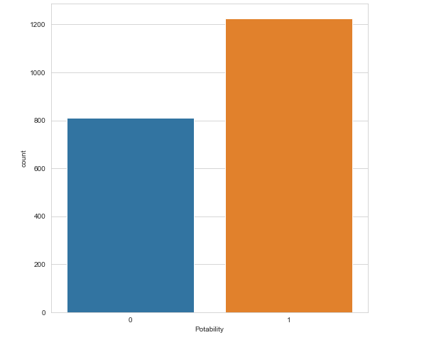

***Figure 1. Frequency plot***

**Figure one displays the bar plot of the target variable. Bar plot is identical for using these types of situations. For example, the target variable is potability data indicating that zero is potable, and one means not potable even if the data type was an integer. Therefore, it should consider categorical data.**

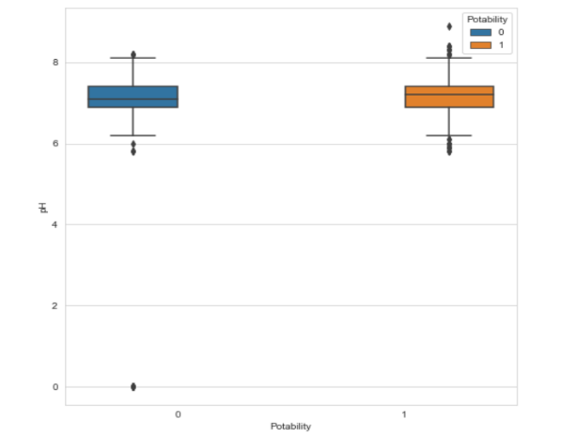

***Figure 2. Box plot Potability and pH***

**This figure displays the box distribution of the ph and potability. Data points display some outliers, where water is potable or not potable, but despite human consumable water or not. There is not much big of a difference between the range of ph. This plot implies that other features involve water potability.**

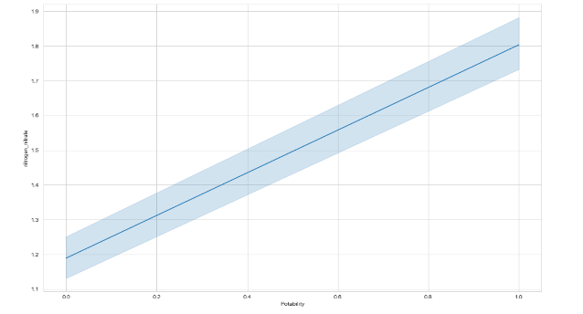

***Figure 3. Line plot***

**This figure displays the line plot between potability and nitrogen nitrate. The plot indicates that nitrogen nitrate increases when water is not drinkable. This plot shows that there is a correlation between potability and nitrogen nitrate.**

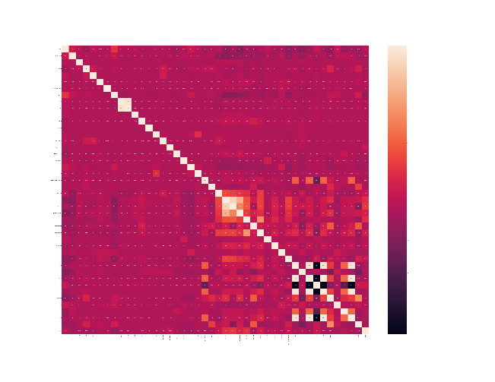

***Figure 4. Heatmap correlation plot***

**This figure displays a correlation between columns using a heatmap. The heatmap shows that most of the correlations between columns are low, which means they are independent do not have linear regression to other features. Darker color indicates that it is negatively correlated with the brighter color, likely correlated.**

1. **Method**

**3-1 Data Preprocessing, Data Splitting**

It is likely to understand that this data is in i.i.d form by reflecting on the data collection source. **Within the data preprocessing stage, the splitting step allocated 20% of the dataset for testing, and the other 80% of the dataset was split into five folds. This means KFoldsSplitting(n=5).One is used for validation in every instance of cross-validation, and the other four folds are used for training purposes. The preprocessor is implemented as StandardScaler for every feature because continuous exploratory data analysis shows that all features are not reasonably bounded.** It means that MinMaxEncoder is not suitable for this dataset preprocessing. As a result, **forty-three features are preprocessed, and** the target variable label is encoded into two categories.

After prepossessing progress data to implement different machine learning models, since the problem is about the classification analysis computing the baseline accuracy score for the prediction is reasonable. As mentioned in figure one, the data set is balanced roughly enough about a four-to-six ratio. Getting correct predictions for two classes is vital for this project, so the accuracy metric was selected.

**3-2 Model Prediction**

For the baseline accuracy rate, the portion of the larger class between the two is equal to 60.21%, which is manageable still considering the dataset is relatively small choosing four methodologies and fitting them with a random training dataset to decide which model would be further researched. This is a result of machine learning model predictions without parameter tuning.

|  |  |  |  |  |
| --- | --- | --- | --- | --- |
| *Machine Learning algorithms* | Logistic Regression | Random Forest | Support Vector Classifier | XGBoost |
| *Accuracy Score* | 0.713235 | 0.884804 | 0.600490 | 0.889706 |

*Table 1. result of machine learning model predictions without hyperparameter tuning*

1. **Results**

**This section displays which methodologies and the hyperparameter tunned showed improvement above baseline and accuracy score.**

**4-1 Logistic Regression**

|  |  |
| --- | --- |
| **Test Baseline:** | 0.6200980392156863 |
| **Test Score:** | 0. 0.7769607843137255 |
| **Standard Deviation of Accuracy** | +/- 0.01 |
| **Optimal Parameter:** | 'logisticregression__penalty': ['l1','l2'],'logisticregression__C': np.logspace(-4, 4, 20) ,solver='saga',max_iter=10000 |

*Table 2. Logistic Regression Hyperparameter*

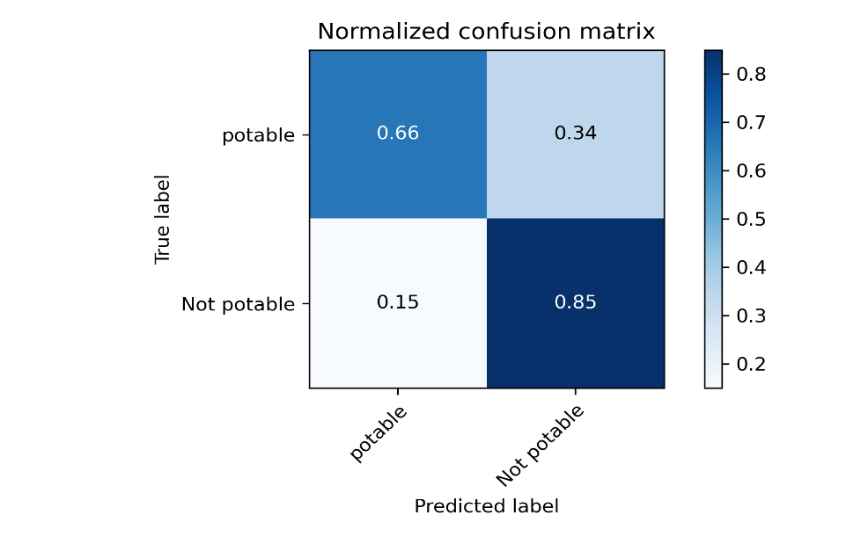

*Figure 5. Normalized confusion matrix for Logistic Regression*

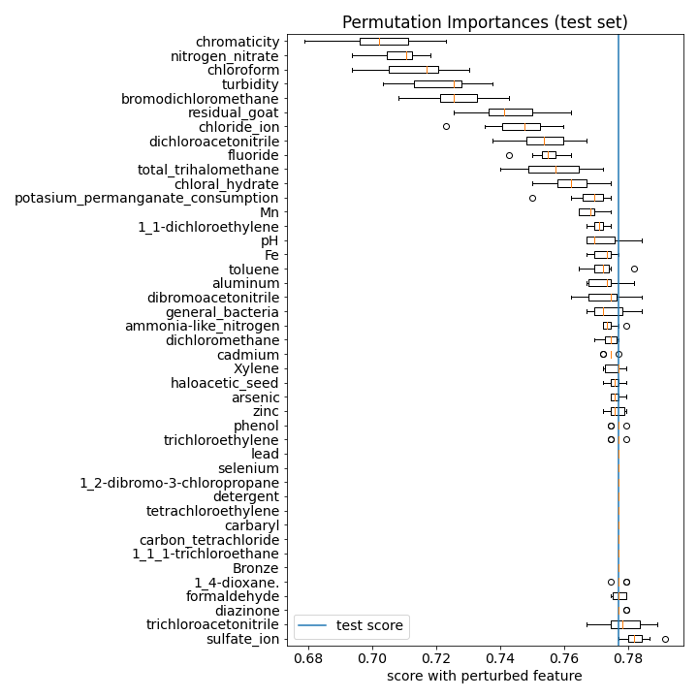

*Figure 6. Permutation importance for Logistic Regression*

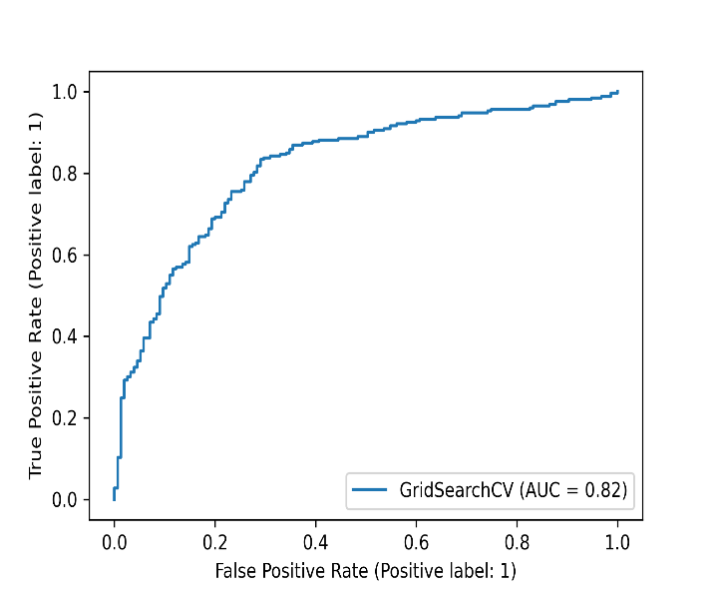

*Figure 7. ROC curve for Logistic Regression*

Using the parameters, above the baseline accuracy of Logistic Regression has been increased by around 2%. Moreover, permutationimportance shows that the sulfate ion is the most crucial random permutation feature. Also, by plotting the ROC curve, AUC can reach 0.82.

**4-2 Random Forest Classifier**

|  |  |
| --- | --- |
| **Test Baseline:** | 0.6200980392156863 |
| **Test Score:** | 0.8700980392156863 |
| **Standard Deviation of Accuracy:** | +/- 0.02 |
| **Optimal Parameter:** | 'randomforestclassifier__max_depth': [1, 3, 10, 25, 50],  'randomforestclassifier__max_features': [0.5,0.75,1.0] |

*Table 3. Random Forest Classifier Hyperparameter*

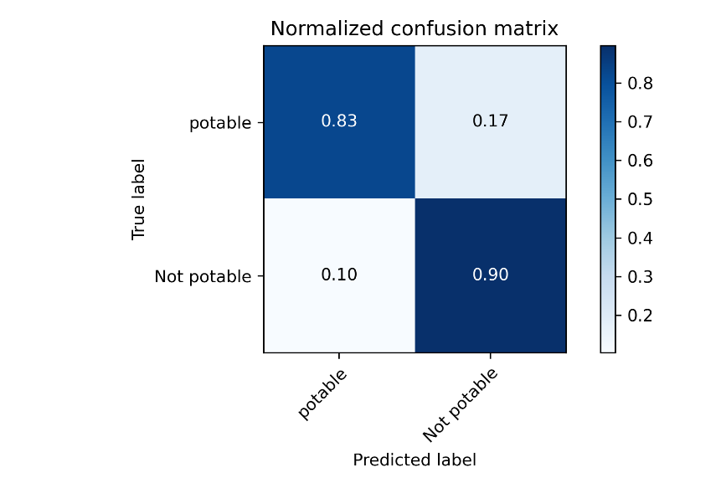

*Figure 8. Normalized confusion matrix for Random Forest Classifier*

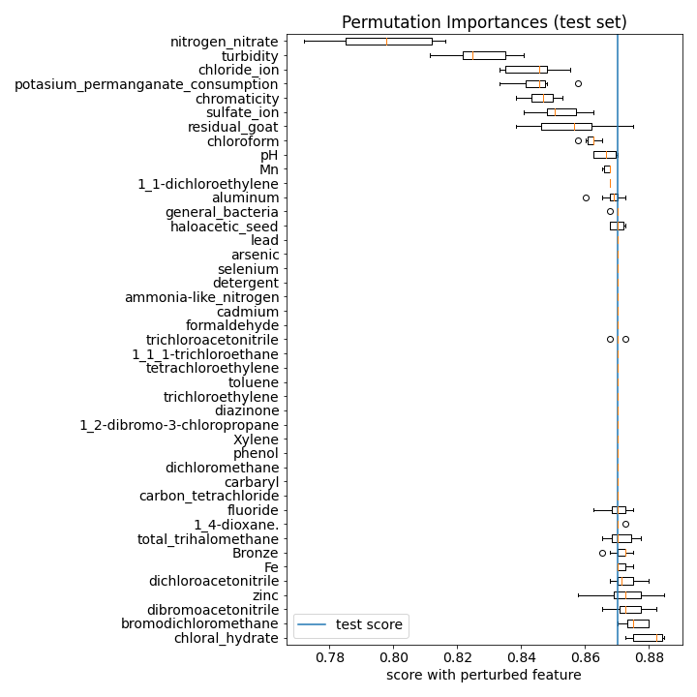

*Figure 9. Permutation importance for Random Forest Classifier*

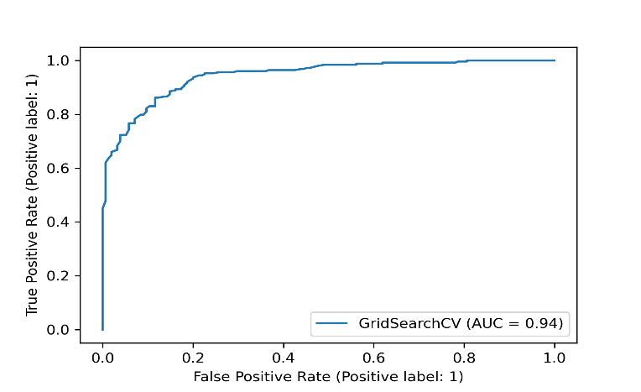

*Figure 10. ROC curve for Random Forest Classifier*

Using the parameters, above the baseline accuracy of the Random Forest classifier has been increased by around 2%. Moreover, permutationimportance shows that chloral hydrate is the most crucial feature. Also, by plotting the ROC curve, AUC can reach 0.94.

**4-3 Support Vector Classifier**

|  |  |
| --- | --- |
| **Test Baseline:** | 0.6200980392156863 |
| **Test Score:** | 0.8700980392156863 |
| **Standard Deviation of Accuracy:** | +/- 0.01 |
| **Optimal Parameter:** | 'svc__c': [0.01, 0.1, 1, 10, 100],  'svc__gamma': [0.01, 0.1, 1, 10, 100] |

*Table 4. Support Vector Classifier Hyperparameter*

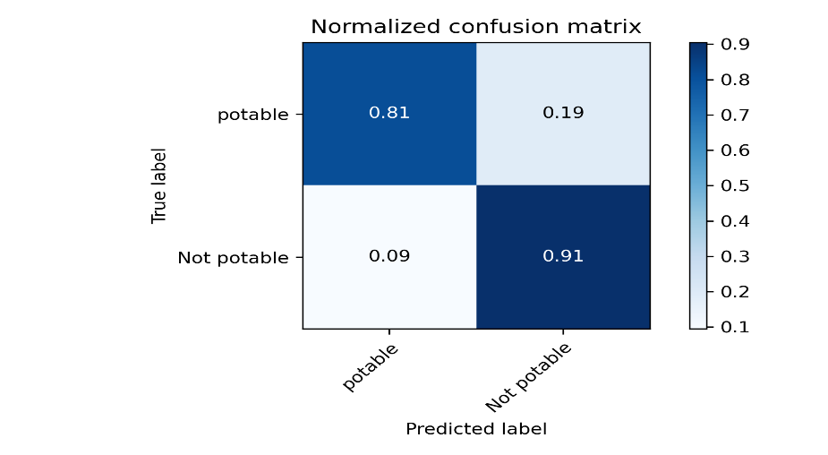

*Figure 11. Normalized confusion matrix for Support Vector Classifier*

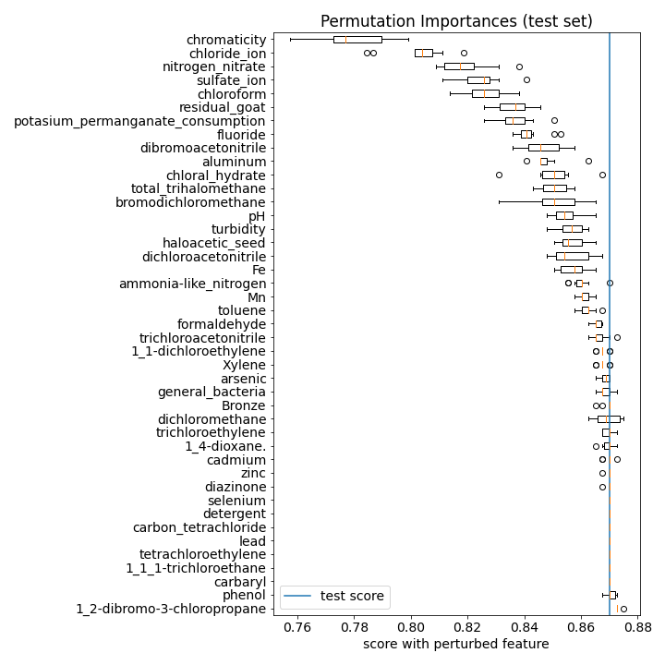

*Figure 12. Permutation importance for Support Vector Classifier*

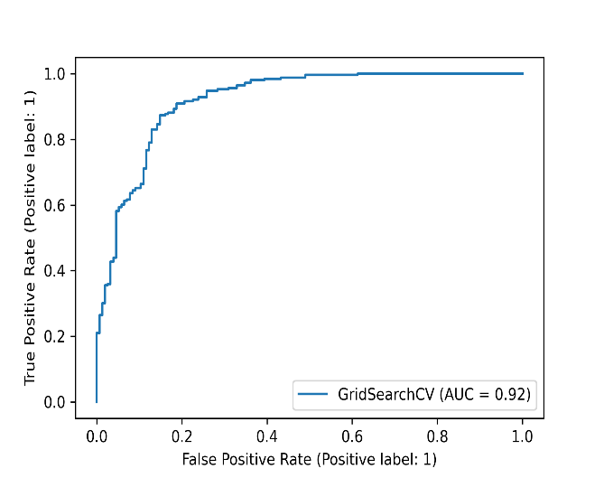

*Figure 13. ROC curve for Support Vector Classifier*

Using the parameters, above the baseline accuracy of the support vector classifier has been increased by around 2%. Moreover, permutationimportance shows that 1-2 dibromo-3-chloropropane is the most crucial feature. Also, by plotting the ROC curve, AUC can reach 0.92.

**4-4 XGBoost**

|  |  |
| --- | --- |
| **Test Baseline:** | 0.6200980392156863 |
| **Test Score:** | 0.8799019607843137 |
| **Standard Deviation of Accuracy:** | +/- 0.01 |
| **Optimal Parameter:** | "xgbclassifier__max_depth" : [ 1, 3, 5, 10, 30, 50, 100],  "xgbclassifier__min_child_weight" : [ 1, 3, 5, 7 ],  "xgbclassifier__gamma": [ 0.0, 0.1, 0.2 , 0.3, 0.4 ]  use_label_encoder=False,n_estimators=100, learning_rate=0.2,subsample=0.66, nthread=1 |

*Table 5. XGBoost Hyperparameter*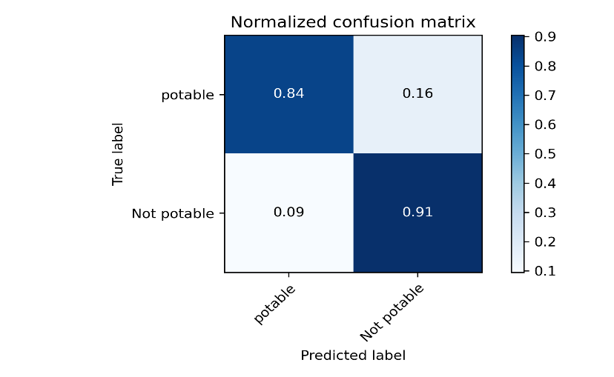

*Figure 14. Normalized confusion matrix for XGBoost*

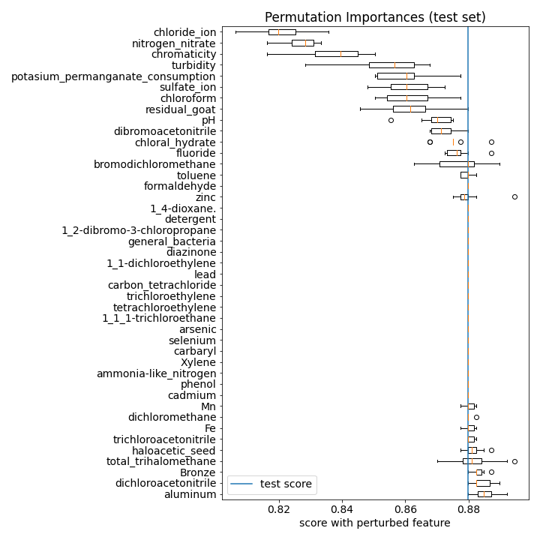

*Figure 15. Permutation importance for XGBoost*

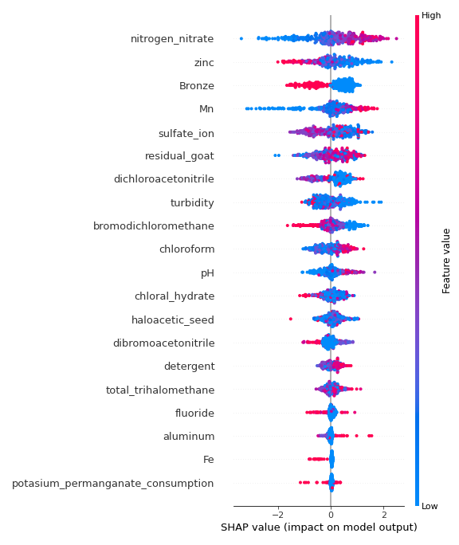

*Figure 16. Summary plot for XGBoost using SHAP*

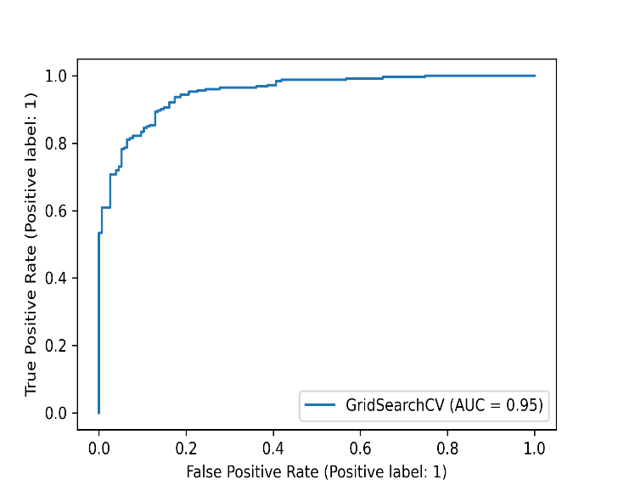

*Figure 17. ROC curve for XGBoost Classifier*

Using the parameters, above the baseline accuracy of the XGBoost classifier has been increased by around 2%. Moreover, permutationimportance shows that nitrogen nitrate is the most crucial feature using SHAP for global permutation importance aluminum. Also, plotting the ROC curve, it can reach 0.95.

Overall Support vector classifier, Random Forest classifier, and XGBoost classifier can be ideal models for this data set. However, choosing one XGBoost will be the suitable model since it displays the highest AUC, 0.95.

1. **Outlook**

**After examing the research for this dataset, the research came out unsatisfactory and created confusion. Before I got the result, I expected turbidity is the critical factor for feature importance; for example, every model shows different importance results globally and locally. For the tunning parameter, further research is necessary to expand the hyperparameter tunning will likely get a better prediction model. Also, advanced deep-learning methods would likely improve the results to get further improvement. Additionally, I researched semi-automated machine learning and automated machine learning from outside the rubric spectrum. Unfortunately, it was not mentioned in this report because, due to lack of experience, it could identically copy the hyperparameter tuning that I used in this project. However, in the end, research, this project gave the experience and insight into machine learning it would indeed be valuable assets for future work.**

1. **Reference**

*A Study on the Turbidity Estimation Model Using Data Mining Techniques in the Water Supply System. (n.d.). Retrieved 2021, from https://pdfs.semanticscholar.org/32b2/0c22003f3bc075a61f44287bde0bdb3aeaa9.pdf.*

1. **Github repository**

**https://github.com/jinnoh47/data1030-project/tree/main**